APPLICATION OF QUALITY CONTROL TOOLS IN ANALYZING DEFECTS IN A DRUM CONTAINER MANUFACTURING INDUSTRY
Jhonrel B. Camelotes^{1*}, Brian D. Genon¹, John Mikel M. Acma ¹, Mary Grace Ann V. Licot¹, Jeric N. Antigua¹, Rosito Cirilo M. Bagayna¹, Consorcio S. Namoco Jr.²
¹ University of Science and Technology of Southern Philippines –Jasaan Campus, Jasaan, Misamis Oriental, Philippines
² University of Science and Technology of Southern Philippines – Cagayan de Oro Campus, Cagayan de Oro City,
Philippines
*Corresponding author’s email: jhonrel.camelotes@ustp.edu.ph

ABSTRACT: Quality tools are the cornerstone of the manufacturing process especially in the drum container manufacturing company. The quality of the products leads to an improvement in productivity and gives satisfaction to the customer. This study aims to conduct a root-cause analysis of drum container defects using quality tools. The quality of container drums plays a vital role in the industry ensuring product information, customer satisfaction, continuous cost reduction, and continuous improvement in a highly competitive environment. Container drum defects mostly occur during the process and it involves the machine, employees, environment, and process therefore, quality tools such as the Pareto chart and Ishikawa or Fishbone diagram are used to identify the root cause of these drum container defects and take actions and recommendations. The research methodology involves analyzing 4 months of data from April to July 2023. By using the Pareto Chart and Fishbone Diagram, the defects identified that there are four main contributors namely; surface rust, paint thin, surface dirt, and paint orange peel. Surface rust had a total defect of 448 from April to July and a cumulative percentage of 29.1%, followed by paint-thin, 261 total defects, a 46.06% cumulative percentage, then surface dirt had 226 total defects and a cumulative percentage of 60.75% and lastly, paint orange peel has a total defect of 200 and has a cumulative percentage of 73.74%. As a result, the company focuses on the four main contributors of defects, especially surface rust which affects the quality of the product. As recommended, a Reinforcement quality management system that includes standard operating procedures, quality control checks, and regular audits to identify and rectify defects early in the production process by using smart, specific, measurable, achievable, relevant, and time-bound.

Keywords: Fishbone Diagram, Pareto Chart, Quality Control Tools, Drum Container Defects, Manufacturing Industry

1. INTRODUCTION
The drum manufacturing company aims to meet the customer’s needs and, the standard of the products to ensure that all the customers are safe and satisfied. Quality tools are the cornerstone of the manufacturing process especially in the drum manufacturing company. In today’s competitive environment, quality control tools are very important because it is not only necessary to reduce wastage but also give satisfaction to the customer’s expectations, continuous cost reduction, and continuous improvement in a highly competitive environment. The importance of quality measurement and improvement has grown over time in the investigation of continuous product and service improvement. The drum container manufacturing company aims to meet the customer’s needs and, the standard of the products to ensure that all the customers are safe and satisfied. Quality tools are the cornerstone of the manufacturing process especially in the drum manufacturing company. In today’s competitive environment, quality control tools are very important because it is not only necessary to reduce wastage but also give satisfaction to the customer’s expectations, continuous cost reduction, and continuous improvement in a highly competitive environment [1].
Quality control consists of analyzing processes, setting standards, comparing performance, verifying and studying defects finding and implementing solutions to obtain better improvements [2]. It is also applied in product development, production, and marketing which involves an improvement in the quality of the products. This study aims to investigate the leading contributors of drum defects that give attention to the employees and managers of the company. Also, it aims to satisfy the customers by delivering defect-free products, reducing wastage, and continuous cost reduction [3].
The method known as "Root Cause Analysis" (RCA) is employed to determine the underlying causes of an issue or an undesirable result. Treating the underlying cause of a problem as opposed to only its symptoms is the aim of root cause analysis [4]. The most commonly used quality tools are the Pareto Chart and Fishbone diagram. It is a widely adopted approach in problem-solving that aims to identify the cause of a certain issue. Pareto analysis is known as an 80/20 rule which suggests that 80% of the effects come from 20% of the causes, it is a statistical approach that helps prioritize the most significant factors contributing to the problem. Also known as the Ishikawa or the cause-and-effect diagram, the Fishbone diagram is a tool that helps to identify the root causes of a problem or its effects. The diagram helps to identify and categorize the possible causes of a problem by breaking down the problem into smaller subcategories [5].
The quality of the product is achieved by minimizing defects and reducing downtime. In many cases, defects occur during the processing, and some defects can be found in raw materials, caused by environments, machines, and manually operated by man. The implementation of quality tools (QTs) and methodologies is necessary to reduce defective items, thus reducing the overall quality costs [6]. Identifying and addressing these issues head-on, it is implemented a comprehensive root cause analysis process to delve into the heart of the matter. By scrutinizing every aspect of the manufacturing process, from material selection to craftsmanship, it is pinpointed the root causes of these defects [7].
In this study, quality tools such as Pareto analysis and Fishbone diagram have been applied to the Root Cause Analysis to identify defects that will benefit the company. It will help provide visualization of the problem, its causes, and their relationship. It will facilitate cross-functional collaboration and sharing of knowledge among the stakeholders involved in drum manufacturing, particularly in the production area [8].
2. MATERIALS AND METHODS
In this study, quality control tools such as the Pareto chart and Fishbone diagram are used in identifying, analyzing, and addressing drum defect issues within a process. Also, a check sheet is used for data collection and analysis.

2.1. Data Gathering
This study was conducted last July to September 2023 in a drum container manufacturing company. With the help of managers and employees, the study was successfully executed
and presented the Root Cause Analysis last November 2023. The data on defects include from April to July 2023.

2.2. Check Sheet
A check sheet, also known as a tally sheet, is a simple and effective tool used for data collection and analysis. It is designed to systematically record and organize data in a structured format, often using tally marks, to facilitate the identification of patterns, trends, or issues. Check sheets are particularly useful in situations where the data needs to be gathered and documented manually and straightforwardly.
The data is plotted on a check sheet to identify the defects every month and to summarize the monthly total of defects and the total of every defect in four months.

2.3. Pareto Chart
A Pareto chart is a graphical representation of data that highlights the most significant factors in a given situation. It is also known as the 80/20 rule which means 80% of the effects come from the 20% causes. Based on the Pareto principle, the Pareto chart shows the idea that a small number of causes frequently account for a big share of issues. Organizations can prioritize efforts to address the most significant issues first by visualizing the frequency or effect of various concerns.
After gathering relevant data, first, identify the list the categories or factors that need to be analyzed based on the data from April to July. Second, assign a frequency that represents the number of occurrences. Next, construct a bar chart using the data of defects and then calculate the cumulative percentage by dividing the cumulative frequency by the total frequency and multiplying by 100. Lastly, analyze the Pareto chart to determine which defects are primarily responsible for the results that have been noticed.

2.4. Ishikawa or Fishbone Diagram
The Fishbone diagram sometimes referred to as an Ishikawa or cause-and-effect diagram, is an organized method for examining and presenting the possible root causes of a particular issue. Its structure, which resembles a Fishbone, divides the various components of an issue into important categories, including people, processes, materials, equipment, and the environment. This graphic aids in thorough Root Cause Analysis, enabling a more profound comprehension of the variables impacting a process's or product's quality.
The Fishbone diagram is used after the result of the Pareto analysis and then identifies the major categories of potential causes related to the issue such as man, machine, method, and materials. After identifying the 4Ms, make sub-causes by using brainstorming and list specific factors under the man, machine, and materials that may contribute to the problem. Make a table for Root Cause Analysis with corresponding actions and recommendations.

3. RESULTS AND DISCUSSION
3.1. Check Sheet

3.1.1. Common Encountered Defects
Based on the data of the company, these are several common factors of defects as stated in Table 1.
There are 16 identified defects in the container drums which are given attention to the management, especially in the production department

Table 1: Common Encountered Defects
Common Encountered Defects
Paint- Orange Peel | Handling/Machine - Scratch
Surface-Dirt | Surface-Peel off paint
Surface- Rust | Surface- Watermarks
Surface- Pinhole | Machine- Overlapping Seam
Paint- Thin | Machine- Sharp Edge
Paint- Sagging | Micro-leak
Paint- No | Machine- Deformed
Handling- Dent | Paint- Off-Color
3.1.2. Total Number of Defects from April to July 2023
Based on the data gathered, eight (8) defects mostly occur during the process and these are the pain-orange peel, surface dirt, surface rust, surface pinhole, Handling machine scratch, paint thin, paint sagging, and surface peel-off paint from April to July 2023 as stated in Table 2.
Table 2. Total Number of Defects from April to July 2023
Defects | Total no. of defects every month
Particular | April | May | June | July | Total
Paint- Orange Peel | 86 | 35 | 31 | 48 | 200
Surface-Dirt | 17 | 77 | 43 | 89 | 226
Surface- Rust | 88 | 132 | 144 | 84 | 448
Surface- Pinhole | 4 | 10 | 22 | 1 | 37
Handling/Machine - Scratch | 13 | 38 | 33 | 72 | 156
Paint- Thin | 155 | 49 | 42 | 15 | 261
Paint- Sagging | 28 | 82 | 2 | 45 | 157
Surface-Peel-off Paint | 20 | 25 | 2 | 7 | 54
Monthly Total | 411 | 448 | 319 | 361 | 1539
As stated in Table 2, there are 1539 total defects from April to July 2023.
3.2. Pareto Chart Analysis for Identified Defects from April to July 2023
3.2.1. Total Defects in 4 Months
As mentioned in Table 2, the total from April to July 2023 is stated in Table 3.
Table 3. Total Defects in 4 Months
Defects | No. of Defects
Particular
Paint- Orange Peel | 200
Surface-Dirt | 226
Surface- Rust | 448
Surface- Pinhole | 37
Handling/Machine - Scratch | 156
Paint- Thin | 261
Paint- Sagging | 157
Surface-Peel-off paint | 54
Total Defects | 1539
3.2.2. Pareto Chart Analysis
To analyze the Pareto chart, the defects mentioned in Table 3 should plotted in a graph to identify the major causes of defects.

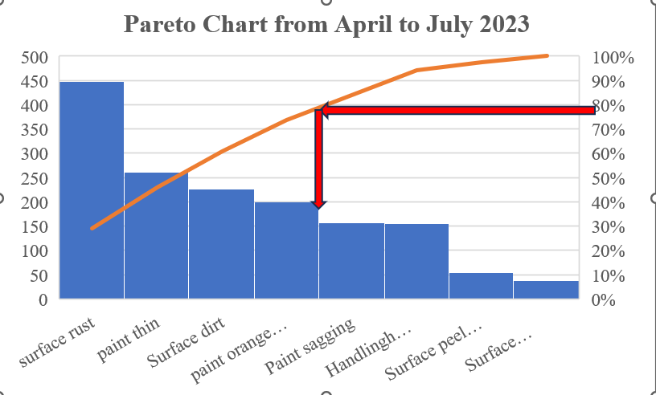

Figure 1. Pareto Chart of Defects from April to July

Upon conducting the Pareto chart analysis, there are four main contributors of defects and based on the Pareto rule, the 80/20 rule, states that, in situations, roughly 80% of effects come from 20% of causes.
As a result, there are four main contributors of defects from April to July namely; Surface rust, Paint thin, Surface dirt, and paint-orange peel. By using the Pareto chart and Fishbone diagram, the defects identified that there are four main contributors namely; surface rust, paint thin, surface dirt, and paint orange peel. Surface rust had a total defect of 448 from April to July and a cumulative percentage of 29.1%, followed by paint-thin, 261 total defects, a 46.06% cumulative percentage, then surface dirt had 226 total defects and a cumulative percentage of 60.75% and lastly, paint orange peel has a total defect of 200 and has a cumulative percentage of 73.74%.
3.3. Fishbone Diagram for Four (4) Major Defects
Based on Figure 1, there are four (4) main contributors to drum container defects namely; Surface rust, Paint thin, Surface dirt, and paint-orange peel.
3.3.1. Fishbone Diagram for Surface Rust
As shown in Figure 2, Issues are categorized by Man, Machine, Method, and Materials.
Based on the Fishbone diagram as shown in Figure 2, the sub-causes are identified based on category. The method has three sub-causes followed by machine, materials, and man. As a result, surface rust is the number one contributor to defects that needs to minimize the defects per month. As mentioned in the sub-causes, those factors should be actioned before production defects arise.

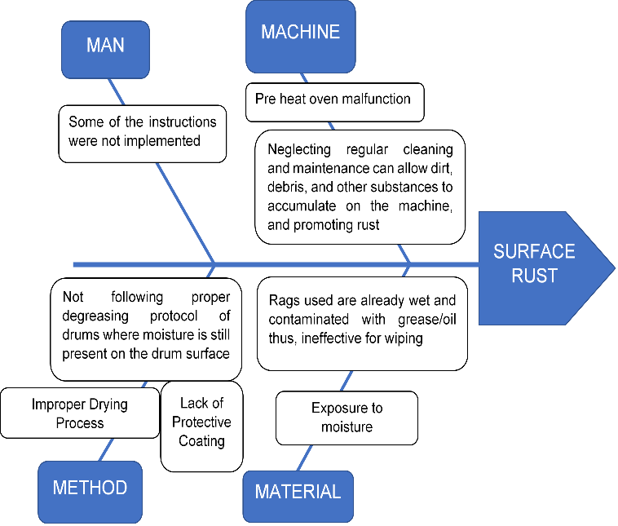
Figure 2. Fishbone Diagram for Surface Rust

Table 4. Root Cause Analysis of Surface Rust
Root Cause Analysis | Action | Recommendation
(Man)  1. Some of the instructions were not implemented | Specific work instructions were provided to the workers regarding the causes of surface rust | Establish manning rotation schedule and inspected daily monitoring and instruction implemented
(Machine)  1. Pre-heat oven malfunction  2. Neglect regular cleaning, maintenance can allow dirt, debris, and other substances to accumulate on the machine, promoting rust | 1. Conduct regular checking  2. Conduct regular cleaning and maintenance of the machine | 1. Improve preventive maintenance schedule.  2. Observe the cleanliness of the machine before and after the operation
(Method)  1. Improper drying process  2. Lack of protective coating  3. Not following the proper degreasing protocol of drums where moisture is still present on the drum surface | 1. Drums should undergo the proper drying process.  2. Implementing regular maintenance for applying the coating.  3 Monitor proper degreasing protocol. | 1. Conduct regular inspections and monitor every process  2. Regular maintenance helps to ensure that the coating on drums remains in good condition.  3. Conduct regular inspection
(Material)  1. Exposure to moisture  2. Rags used are already wet and contaminated with grease/oil thus, ineffective for wiping | 1. Involve drying, repairing, or replacing components  2. Reinforce rag usage and the no. of drums per rag. | 1. Conduct regular line audit/ verification  2. Using moisture-resistance materials, to avoid moisture-related problems.
As presented in Table 4 presents the Root Cause Analysis with the corresponding action taken and recommendation. These involve the man, machine, method, and materials and by these categories, the sub-causes specify and give actions and recommendations based on the problem stated. Moreover, surface rust has always been seen if this action and recommendation will be taken for granted.
3.3.2. Fishbone Diagram for Paint-Thin
Figure 3 shows the Issues are categorized by Man, Machine, and Method
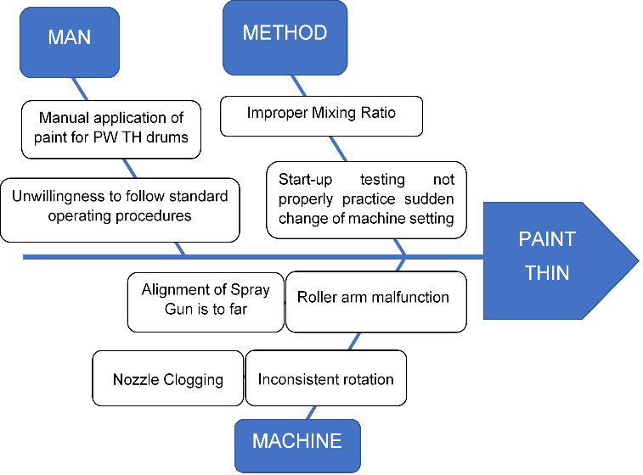
Figure 3. Fishbone Diagram for Paint-Thin

As shown in Figure 3, Paint-thin is the second defect to surface rust. This is done during the paint process and the defects are identified during the pre-heat oven.

Table 5. Root Cause Analysis of Paint Thin
Root Cause Analysis | Action | Recommendation
(Man)  1. Manual application of paint for PW TH drums  2. Unwillingness to follow standard operating procedures | 1. Set minimum drums for painting to lessen fatigue.  2. Re-orient and remind of everyday toolbox meetings. | 1. Physical well-being by managing workload  2. ongoing communication and establishing regular toolbox meetings.
(Machine)  1. The alignment of the Spray Gun is too far  2. Nozzle Clogging  3. Roller arm malfunction  4. Inconsistent rotation | 1. Optimize Material Alignment  2. Improve and strict implementation of start-up machine verification.  Improve and strict implementation of start-up machine verification. | 1. Monitor from time to time for the alignment of the spray gun  2. Implement a routine inspection schedule to identify early signs of rust or clogging.
(Method)  1. Start-up testing does not properly practice Sudden changes of machine settings"  2. Improper mixing ratio | 1. Reinforce no testing and no start-up per area. Improve daily monitoring records with remarks—daily toolbox meetings for any issues and concerns, regarding the quality. | 1. Conduct training sessions about the no testing and no start-up policy.  2. Conduct and monitor from time to time  The consistency, viscosity, and thinness.
As presented in Table 5, paint-thin shows the issues under the man, method, and machine. The company focuses on the machine which is stated that the root cause analysis has four sub-causes namely; nozzle clogging, alignment of spray gun is too far, roller arm malfunction, and inconsistent rotation. These identified defects are costly because of materials not just the drum but also the paint spreading to the body of the drums.
The action and recommendation will help the company to minimize the Paint-thin defects and increase production per month as stated in Table 2.
3.3.3. Fishbone Diagram for Surface Dirt
As shown in Figure 4, issues are categorized by man, machine, method, and materials.

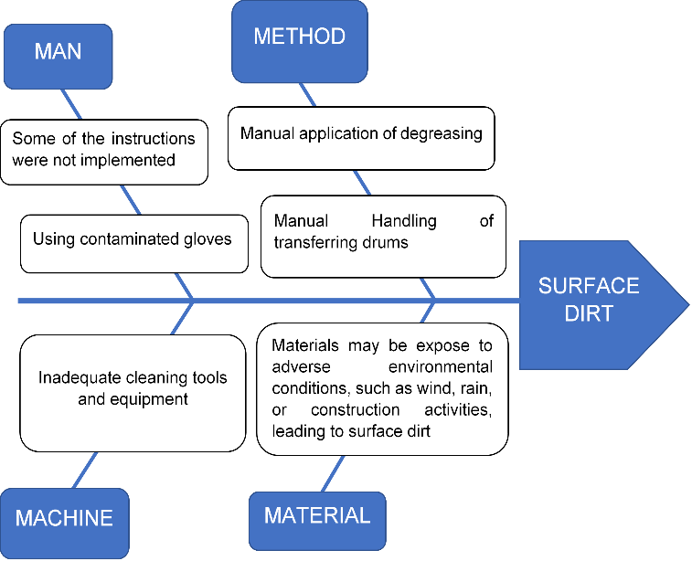
Figure 4. Fishbone Diagram for Surface Dirt

Surface dirt is one of the major defects as shown in figure 4. It is caused mostly in every process as mentioned in man, method, machine, and material. The production head has a concern about the manual application of degreasing and manual transferring of drums.
As presented in Table 6, Surface dirt has four (4) categorized issues, and under this are the sub-causes. The production department has focused on the method which is suggested to have a new design of machine for degreasing and also provides a machine for transferring the drums.
To conclude, the maintenance, and production department has a plan to design a new machine for fast production and to minimize the surface dirt in a container drum.
As illustrated in Figures 2, 3, and 4, a comprehensive analysis reveals various sub-causes contributing to surface rust, paint thinning, and surface dirt. These issues encompass a range of factors, including human actions, machinery, methodologies, and materials. Specifically, surface rust and surface dirt are categorized into four distinct groups: man, machine, method, and material while paint thinning presents three categories, excluding material, yet still encompassing critical aspects such as human behavior, equipment functionality, and procedural methodologies.
issues.
Table 6. Root Cause Analysis of Surface Dirt
Root Cause Analysis | Action | Recommendation
(Man)  1. Inadequate cleaning practices  2. using contaminated gloves and rags | 1. Cleaning processes should performed regularly, allowing dirt to accumulate on surfaces.  2. Make sure that the gloves and rags are clean and do not use recycled gloves and rags | 1. Implement and enforce regular and thorough cleaning protocols. Ensure that cleaning agents and methods are effective for the specific surfaces.  2. Replace new rags and gloves from time to time.
(Machine)  1. Inadequate cleaning tools and equipment | 1. Regularly inspect and maintain cleaning tools to ensure their effectiveness. | 1. Invest in appropriate cleaning tools and equipment. Regularly inspect and maintain cleaning tools to ensure their effectiveness.
(Method)  1. Manual application of degreasing  2. Manual Handling of transferring drums | 1. Provide always new rags for degreasing.  2. Minimize the manual handling of transferring drums from the first process to the last. | 1. Design a machine for degreasing  2. Provide a machine for transferring the drums
(Environment)  1. Materials may be exposed to adverse environmental conditions, such as wind, rain, or construction activities, leading to surface dirt. | 1. Improve storage conditions by using proper covering, sealing, or storing materials in enclosed spaces to prevent exposure to dirt. | 1. Improve storage conditions by using proper covering, sealing, or storing materials in enclosed spaces to prevent exposure to dirt.

Moreover, these findings reveal a comprehensive understanding of the contributing factors to these common
3.3.4. Fishbone Diagram for Paint-Orange Peel
Based on Figure 5, issues categories by Man, Machine, and Method.
As shown in Figure 5, paint orange peel is also a defect that occurs in the drum and this is one main contributor from April to July 2023.
Under the man, method, and machine are the sub-causes which the method has got attention to the company because of improper paint viscosity, previous coat insufficiently, and
improper mixing ratio. It also includes the machine and under the incorrect spray gun, Incorrect adjustment of the application equipment, and failure to adjust the hardener and thinner to room temperature. Additionally, the man who contributes to the manual application of paint drums, and unwillingness to follow standard operating procedures.

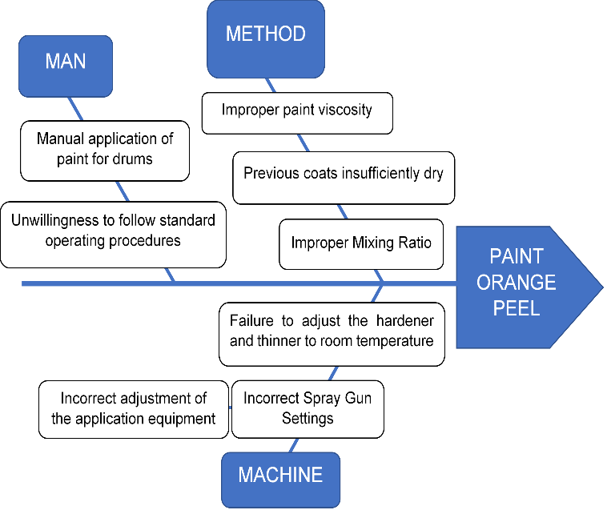

Figure 5. Fishbone Diagram for Paint-orange Peel

As a result, Table 7 states the root cause analysis is identified with corresponding action and recommendation. The occurrence of paint orange peel is characterized by a textured surface of the drums that gives orange color, it can result from various factors in the painting process. The issue contributed under man, method, and machine. To address this problem and give a solution to these defects, actions, and recommendations should be implemented during production.

Paint-Orange Peel and Paint-thin has a similar when it comes

to defects and sub-causes are identified by similarity. The action and recommendation are always focused on the painting process.

To conclude, the paint-orange peel is one main contributor to defects from April to July 2023 and leads to an alarming situation for the company. With this action and recommendation, the quality of production will be increased, minimizing the defects per month and giving satisfaction to the customer.
Table 7. Root Cause Analysis of Paint-Orange Peel
Root Cause Analysis | Action | Recommendation
(Man)  1. Manual application of paint for drums  2. Unwillingness to follow standard operating procedures | 1. Set minimum drums for painting to lessen fatigue.  2. Re-orient and remind of everyday toolbox meetings. | 1. Physical well-being by managing workload  2. ongoing communication and establishing regular toolbox meetings.
(Machine)  1. Incorrect Spray Gun Settings  2. Incorrect adjustment of the application equipment.  3. Failure to adjust the hardener and thinner to room temperature | 1. Optimize spray gun Alignment  2. Improve the adjustments of the machine, especially in the painting process.  3. Monitor from time to time the temperature of the oven. | 1. Monitor from time to time for the alignment of the spray gun  2. Daily inspection and monitoring.  3. Monitor the room temperature or environmental conditions so that the adjustment to be applied according to its drying speed.
(Method)  1. Improper paint viscosity  2. Improper Mixing Ratio  3. Previous coats insufficiently dry | 1. Just to make sure that the viscosity is exactly what is required for the specific drums  2. Analyze the paint's consistency, viscosity, and thinness.  3. Always comply with the drying time of the base coats specified in the technical data sheets of each product. | 1. Daily inspection and monitoring  2. Conduct and monitor from time to time  The consistency, viscosity, and thinness.

4. CONCLUSION AND RECOMMENDATION
To conclude, the faults on the drum are mentioned in Table 1, and by using the Pareto chart and fishbone diagram, the defects of the drum have four main contributors which include surface rust, thin paint, surface dirt, and paint orange peel, highlight the significance of a thorough quality control and manufacturing process. Not only do these problems affect the drums' visual appeal, but they also pose a risk to their long-term durability and structural integrity. Addressing these concerns requires the following;
- Conduct a visual inspection of the drums to identify physical defects such as dirt, scratches, corrosion, or paint irregularities.
- Investigate the Root Cause, strengthen weak areas, ensure proper assembly, and adhere to weight limits to prevent defects
- Review records related to drum production, quality checks, and incidents of defects.
As a recommendation, a reinforcement quality management system that includes standard operating procedures, quality control checks, and regular audits to identify and rectify defects early in the production process is highly suggested to be put in place. Moreover, employees should be encouraged to proactively identify defects and involve them in problem-solving and decision-making processes.

REFERENCES

[1]. Deepak, Dheeraj Dhingra. "Application of quality control tools in bicycle industry: A case study." International Journal of Research in Engineering and Technology 5, no. 07 (2016): 119-127.
[2]. Fuentes, Genesis B., Edbis S. Sevilla, Marynick G. Tabacon, Romelina T. Lagamon, and Consorcio S. Namoco Jr. "Utilizing Statistical Quality Control (SQC) Tools for Analyzing Defects in A Small-Scale Local Shoes Production Company." Sci. Int. (Lahore) 35, no. 5 (2023): 639-642.
[3]. Romano A. Pimentel, Dexter L. Duat, Paul Joseph Estrera, Al-rashyn M. Sayadi, Consorcio S. Namoco Jr. Utilizing Statistical Quality Control Tools in Improving the Quality of the Weights of Animal-Feed Bags. Sci.Int. (Lahore), 34(5), (2022), 441–445
[4]. Vincent Adolph E. Vigor, Jonathan B Calibara, Lloyd Jhon B Estampa, Marie Ninia A Estillore, Consorcio S Namoco Jr. The Use of Statistical Quality Control Charts In Monitoring the Cost and Project Duration of A Columbarium Construction Project Utilizing Concrete Composite Panels. Sci.Int. (Lahore), 34 (4), (2022)pp.349-353.
[5]. Raman, Ravi Shankar, and Yadavalli Basavaraj. "Quality improvement of capacitors through fishbone and Pareto techniques." International Journal of Recent Technology and Engineering 8, no. 2 (2019): 2248-2252.[6]. Fernando T. Capilitan, Jr., Joan Grace Q. Duero, Junnafe D. Daleon, Anabelle C. Dumaog, Consorcio S. Namoco, Jr. Assessment on The Performance of Teacher Education Graduates in The Licensure Examination For Teachers (LET) Using Statistical Quality Control: A Case Study of the University of Science and Technology of Southern Philippines Cagayan De Oro. Sci. Int. (Lahore), 34(3), (2022). 327–330
[7]. Gil G Hagutin, Joey P Roger, Michelle C Lastimosa, Demi Jas P Naive, Consorcio S Namoco Jr. Utilization of Statistical Quality Control (SQC) Tools in Evaluating the Self-Learning Modules for Basic Education. Sci.Int. (Lahore), 34 (4) (2022), pp.367- 371.
[8]. Jipos, M. A. C., Jamito, C. P., Camelotes, J. B., Baguio, R. H., & Namoco Jr, C. S. Root-Cause-Analysis of Recurring Flour Packaging Printing Defects Utilizing Quality Control Tools. Sci. Int. (Lahore) (2023)

